# **virtual machine?**

In its simplest form, a virtual machine, or VM, is a digitized version of a physical computer. Virtual machines can run programs and operating systems, store data, connect to networks, and do other computing functions. However, a VM uses entirely virtual resources instead of physical components.

VMs enable businesses to create isolated environments on host hardware that behave like separate machines. A more straightforward way to understand what a virtual machine is to think of it as a virtual computer within another computer. But instead of a physical computer like a server, laptop, or smartphone, a VM is defined by software.

Much of the technology we benefit from today, such as [cloud computing](https://cloud.google.com/learn/what-is-cloud-computing) and [artificial intelligence](https://cloud.google.com/learn/what-is-artificial-intelligence), is rooted in the concept of the virtual machine, which allows operating systems and software to be separated from a physical machine. For instance, VMs in cloud computing are used to virtualize the resources of cloud service providers’ servers, enabling the multi-tenant cloud architecture that allows customers to share resources.

## 

## How do virtual machines work?

## Virtual machines use virtualization technology to create virtual hardware—or a virtual version of a computer on a physical machine. The physical machine on which the VMs run is called the host, and the VMs running on the host are called guests.

## Each guest VM runs on an isolated partition on the host, completely separated from other guests. You can host multiple VMs on a single host machine, often a server, running on a software layer known as the hypervisor.

The hypervisor abstracts the host machine’s physical resources, such as compute, memory, or storage, into a pool that can be provisioned and dynamically allocated to guest VMs as needed, providing more flexibility and increasing overall efficiency.

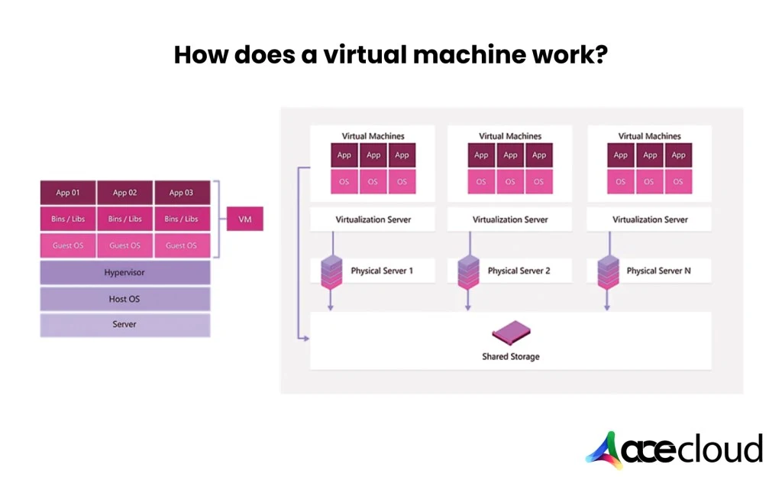

## 

## 

## Types of virtual machines

Generally speaking, there are two types of virtual machines: process VMs and system VMs.

* Process VM: A process VM, also called an application virtual machine or managed runtime environment (MRE), creates a virtual environment of an OS while an app or single process is running and destroys it as soon as you exit. Process VMs enable creating a platform-independent environment that lets an app or process run the same way on any platform.
* System VM: A system VM (sometimes called hardware virtual machines) simulates a complete operating system, allowing multiple OS environments to live on the same machine. Typically, this is the type of VM people are referring to when they talk about “virtual machines.” System VMs can run their own OS and applications, and a hypervisor monitors and distributes the physical host machine’s resources between system VMs.